|  |  |  |  |  |  |
| --- | --- | --- | --- | --- | --- |
| Date | 11-Dec-22 | | | Tester Name | Andrew McLaughlin |
| Environment | Penfax - Test | | | Login used | TEST2 |
| Operating System | Windows | Version: | Update: | | |
| Software Used | Edge | Version: | Update: | | |
| Not Applicable | Version: | Update: | | |
| Release version | 22.4.1 | | | | |
| Title | M51.02 Annual Statement Batch - Ad-hoc Batch | | | | |
| Test Type | Regression | | | | |
| Test Scenario | Run Statement Batch for Actives only | | | | |
|  |  | | | | |
| Expected Results |  | | | | |
| Pass/Fail | Pass | | | JIRA# | N/A |

Describe your steps with screenshots:

Set up the Batch

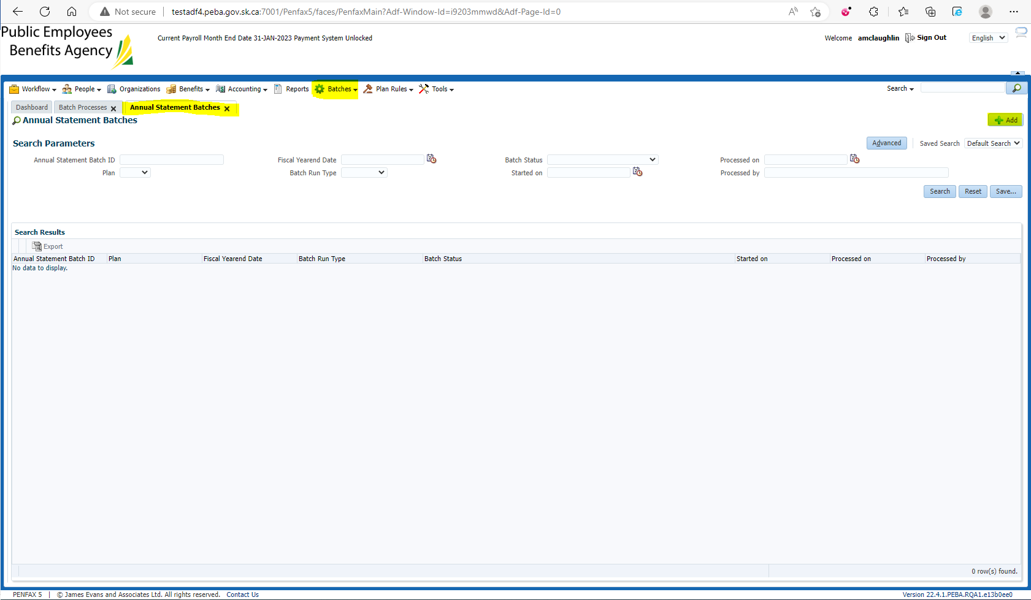

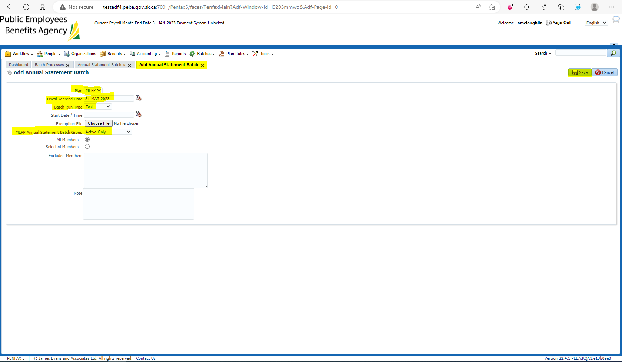

When the batch has been completed successfully, check the Files tab to ensure the files are all there

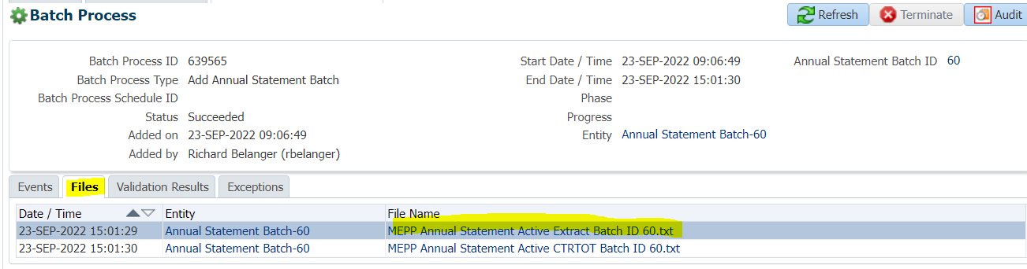

Text File-Active

